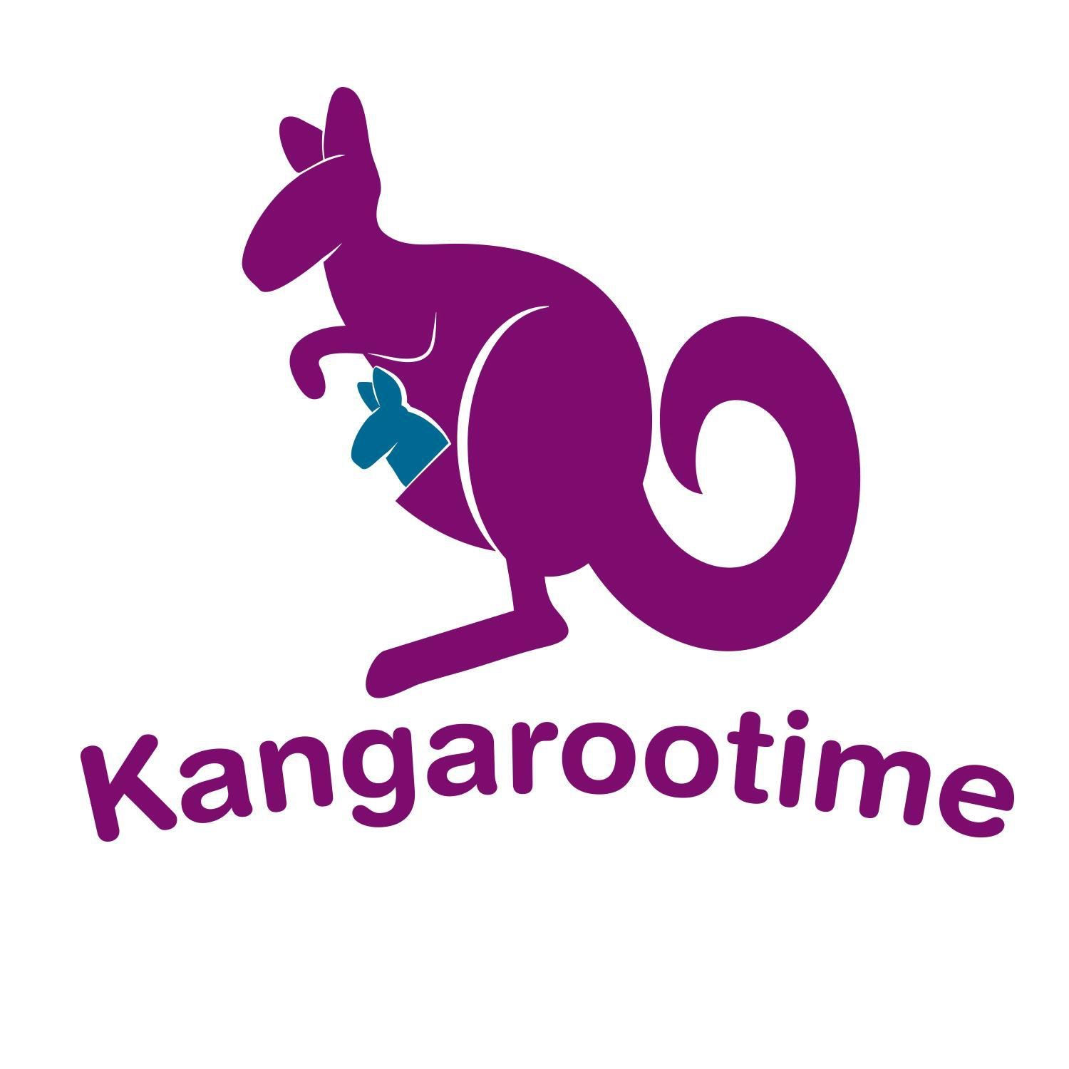
Dear Parents & Guardians,

We are excited to announce that we utilize a revolutionary app at our center to make things simple to manage and improve parent connectivity. It’s called Kangarootime! This system is located in the “cloud” so it works with all computers, tablets, and smartphones, both iPhones and Android.

Please review the following information and register your Kangarootime account as soon as you receive the email invitation.

The program provides many benefits that will streamline our center processes, improve security for all the children we care for, and provide a new and enhanced experience for our parents and trusted guardians.

Some of the new features you will enjoy with Kangarootime are:
- Secure Child Check In and Out
- Ability to view photos and daily notes of your child’s day
- Secure messaging with the childcare center
- View the calendar of events
- Update your child’s allergies, emergency contacts, and upload documents
- Pay your tuition bill online via credit card or checking account through a secure portal
- Access your financial statements for tax or employer purposes!

Soon, one member of your family will be receiving an invitation via e-mail to register your family in the Kangarootime platform. One person per family registers as the
primary account holder, who will then invite guardians (any other parents, family members, or persons connected to the care of your children.)

Part of this registration process will include uploading photos of you and your children to help ensure optimal security during Check In and out, so please take a few minutes to snap a ‘selfie’ or find recent individual pictures that clearly show your faces!

Once you receive the invitation, please take the time to register promptly so you can begin enjoying all the great benefits that this new system will provide and don’t forget to download the free Kangarootime mobile App!

Thanks for your support and have a fantastic day!

Sincerely,
Theresa

